Angle 36, Speed 10

Result Log for stopping experiment with accuracy at cycleAccuracy 0.7333333333333334

reaching stable after enter newborn cycle 330.

Elapsed time: 4 min.

circle reach average Accuracy 0.8

rectangle reach average Accuracy 0.5714285714285714

triangle reach average Accuracy 0.8285714285714286

Stop SP+TM after 9 cycles

Elapsed time: 3 min.

Angle 72, Speed 10

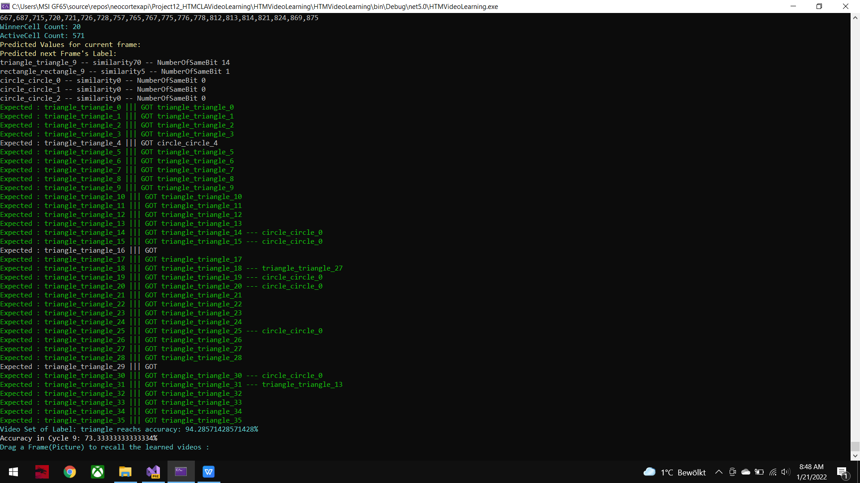

Angle 108, Speed 10

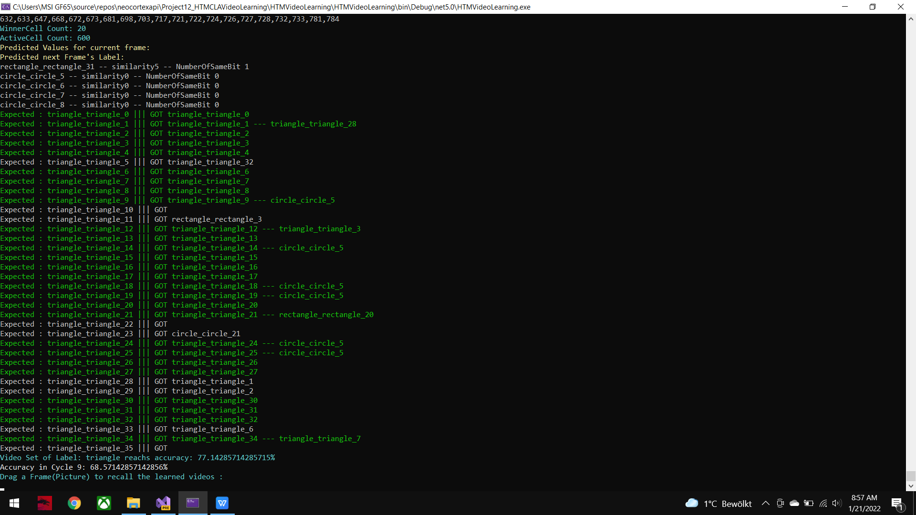

Angle 144, Speed 10

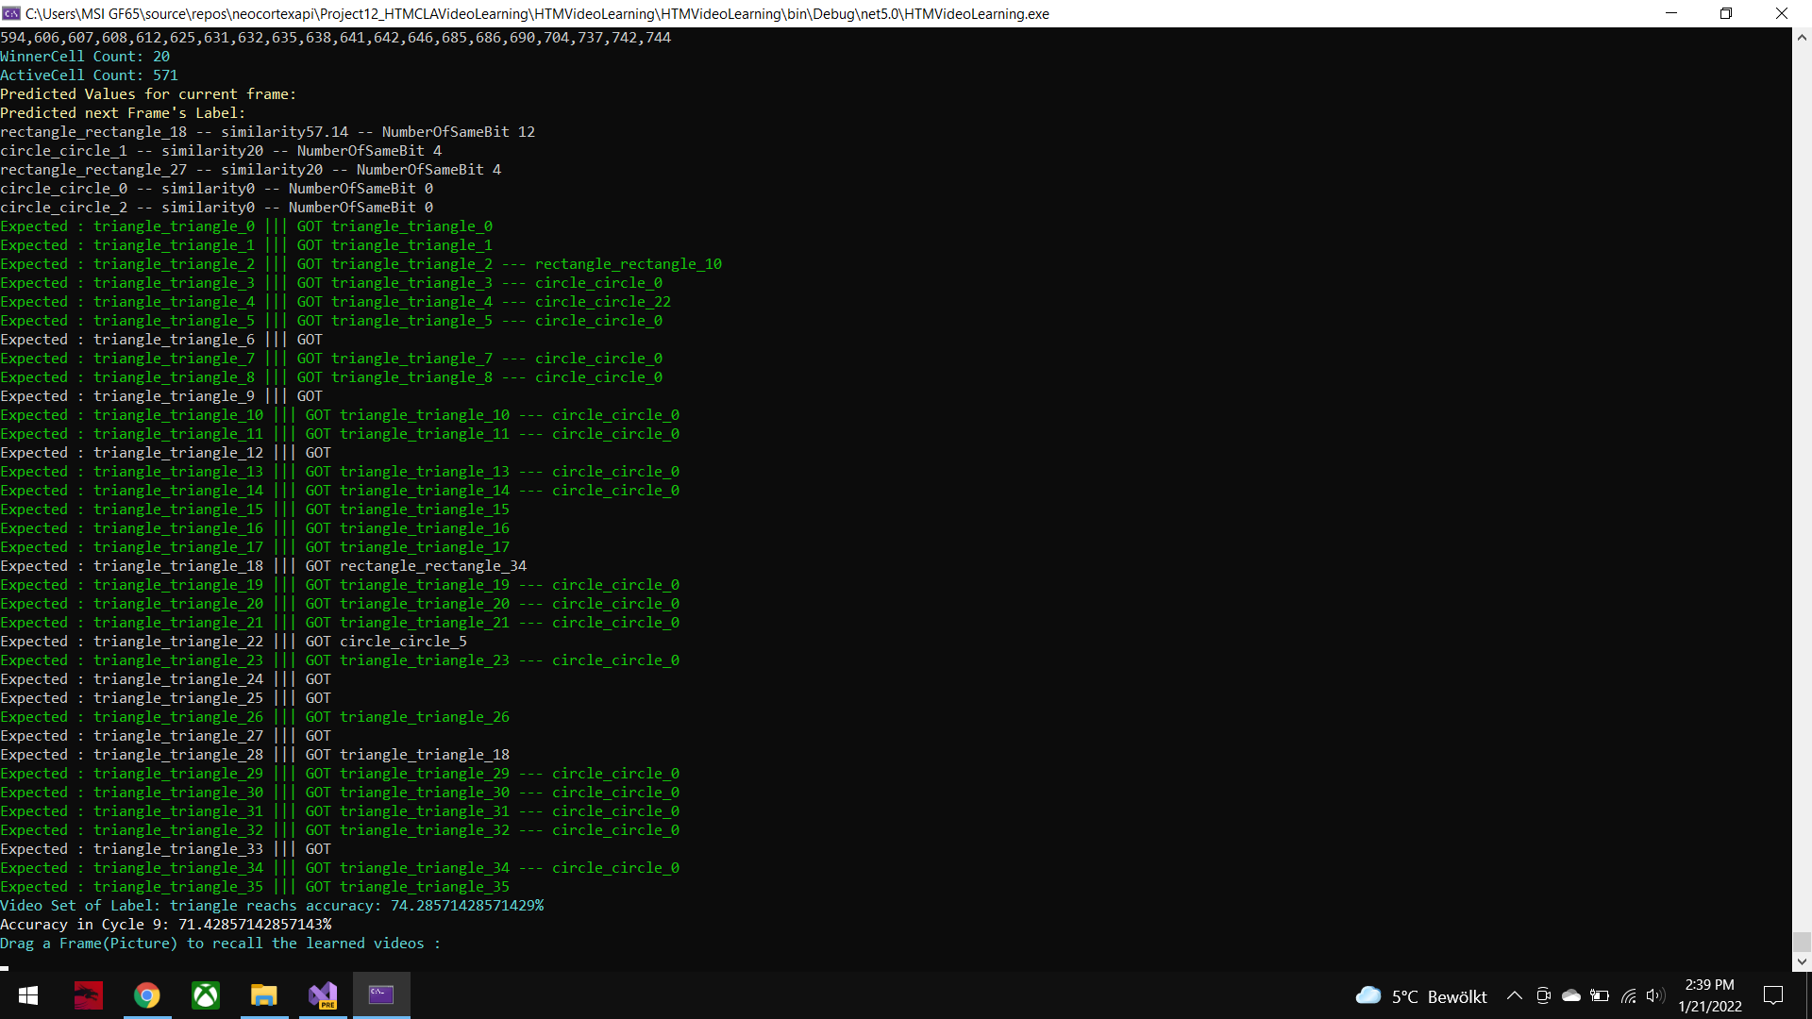

Angle 180, Speed 10

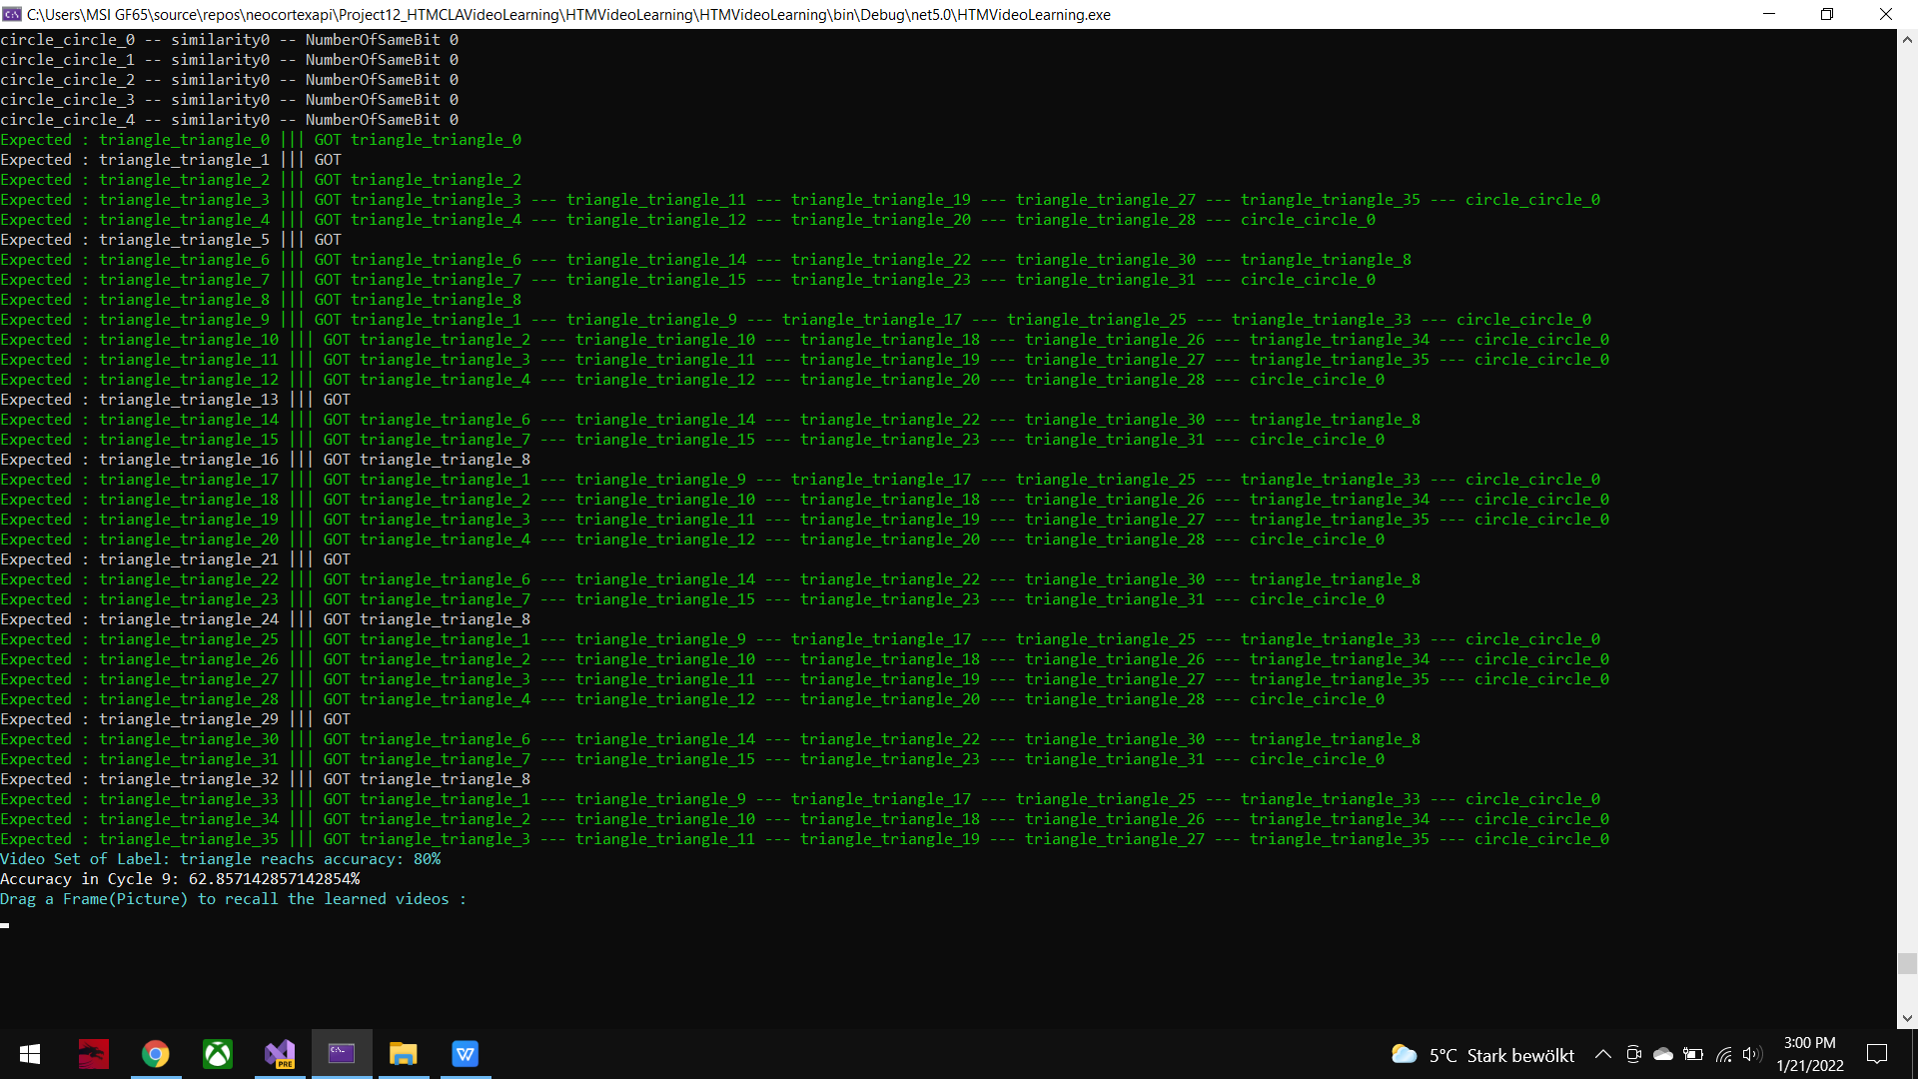

Run2 requires much longer run time than Run1

Angle 36, Speed 10

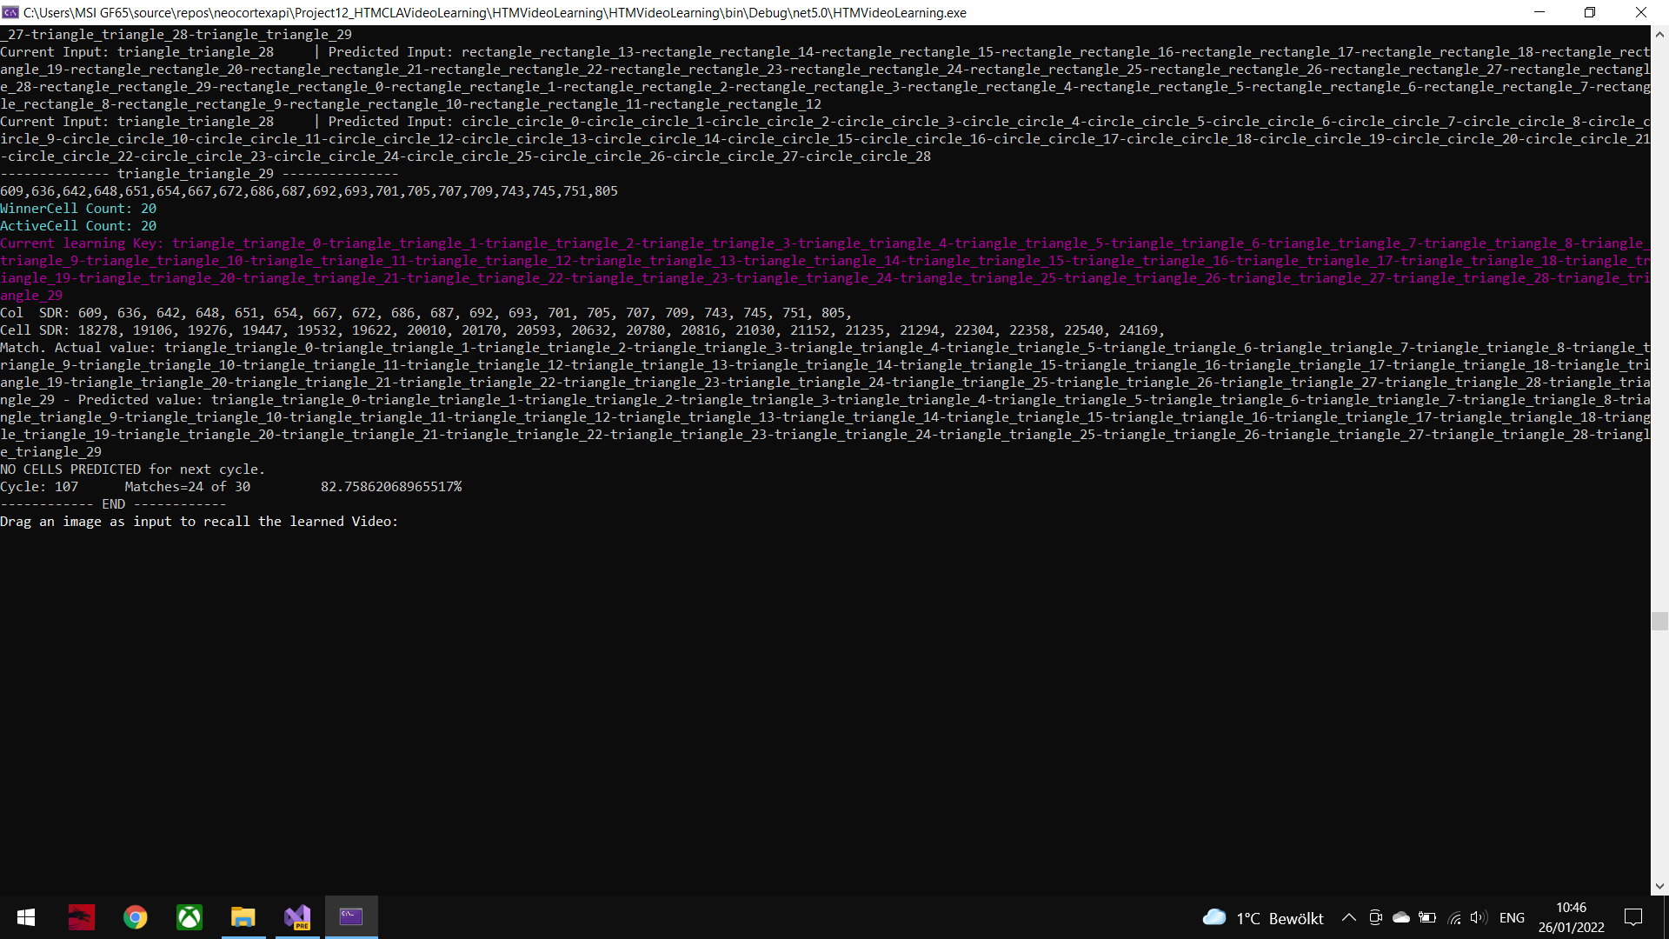

Angle 72, Speed 10

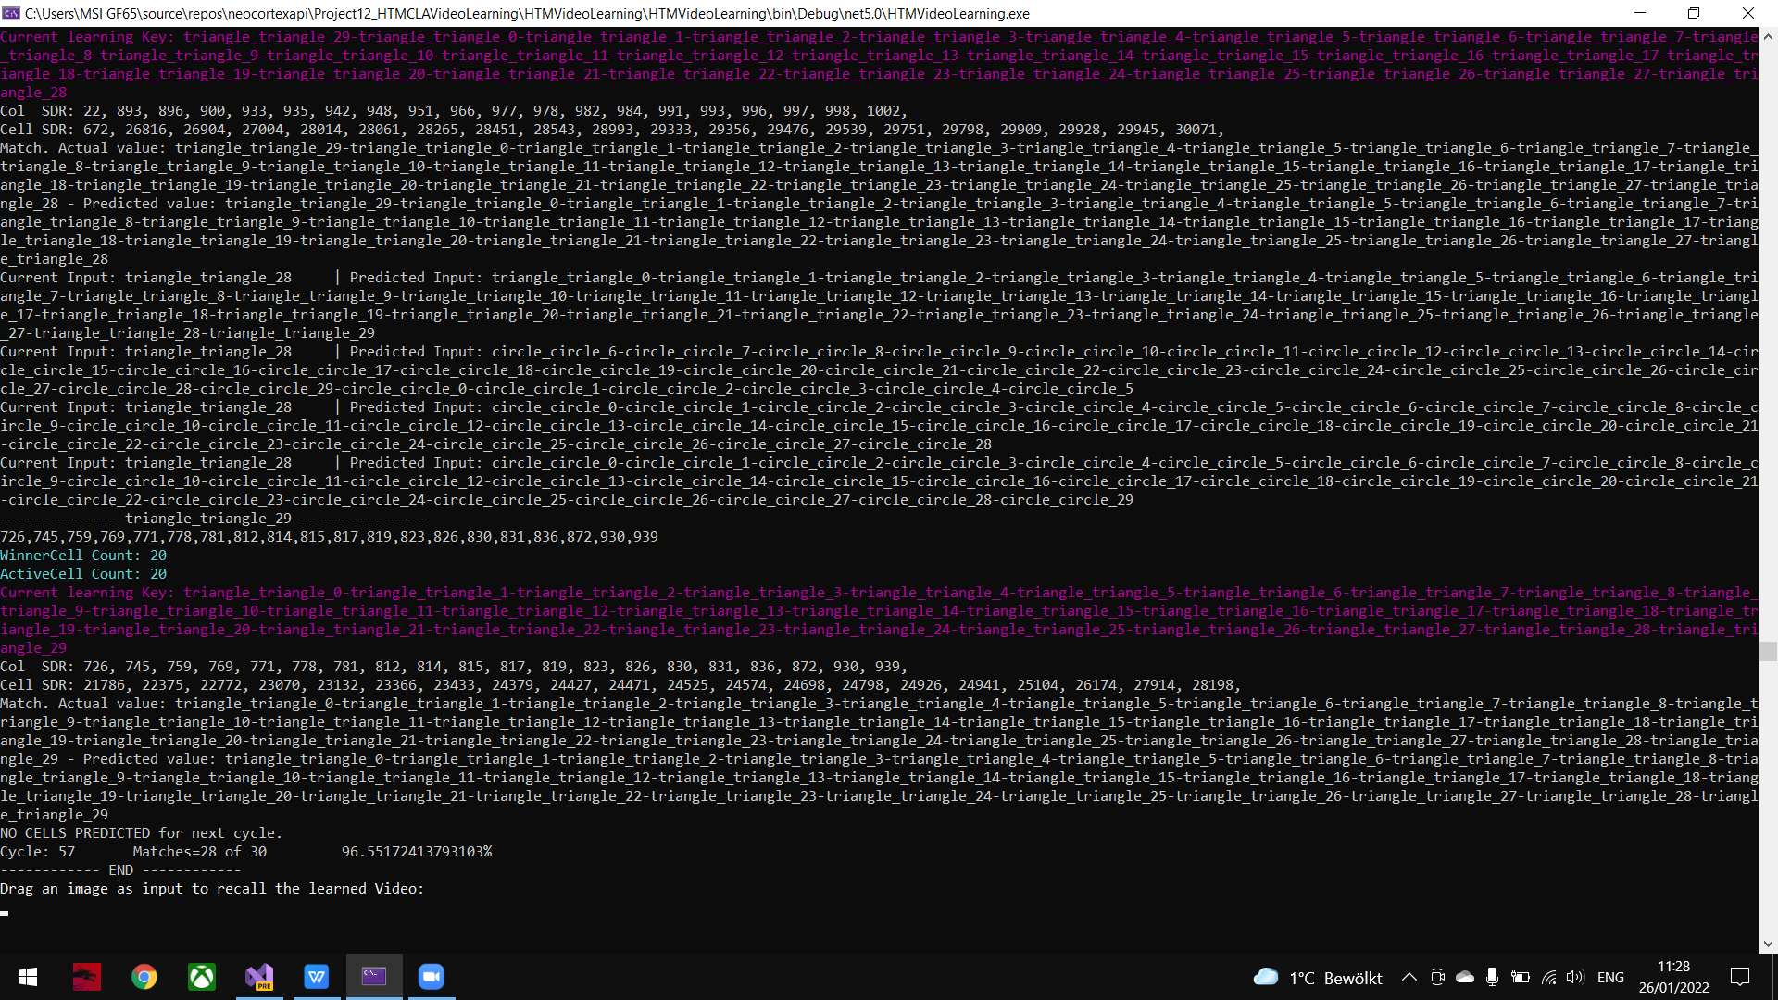

Angle 108, Speed 10

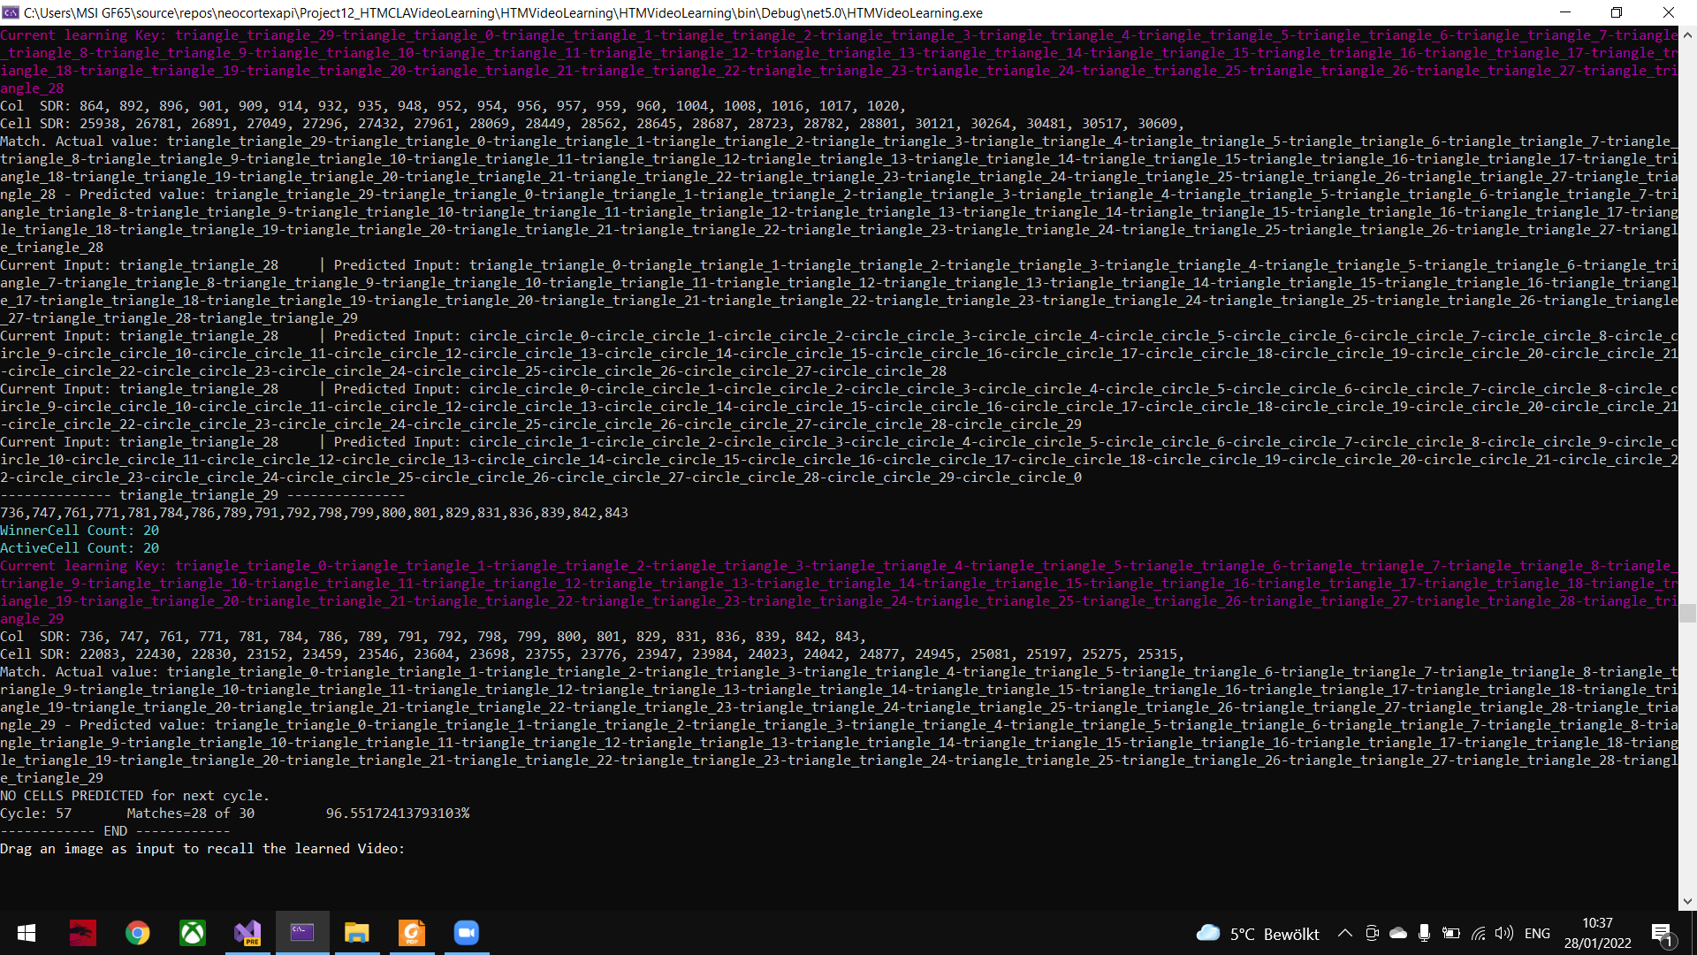

Angle 144, Speed 10

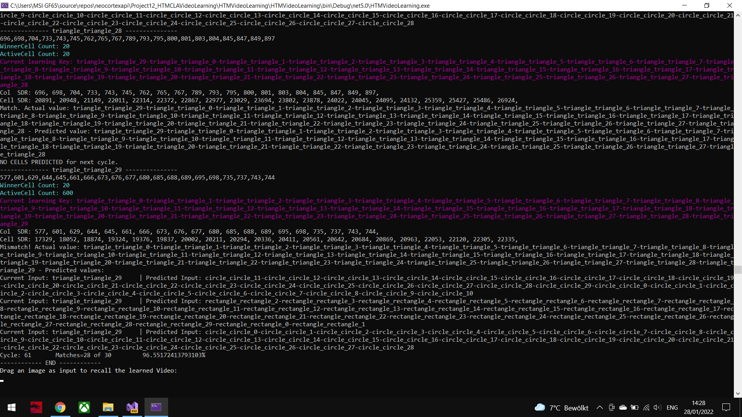

Angle 180, Speed 10 (run for more than 1 hour)

